C:\Users\vmohr\AppData\Local\Microsoft\Windows\Temporary Internet Files\Content.IE5\6PG8U8ZR\MC900030117[1].wmf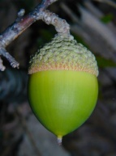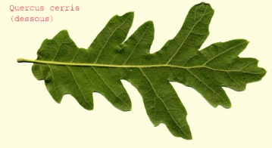[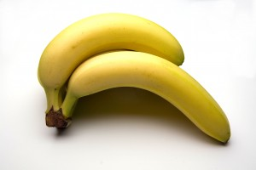](http://www.klesickfamilyfarm.com/main/wp-content/uploads/2011/06/bananas2.jpg)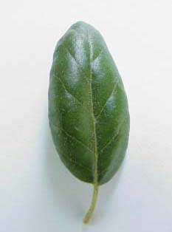

Circle the leaf and the seed that belong to each tree.



Live Oak Tree

[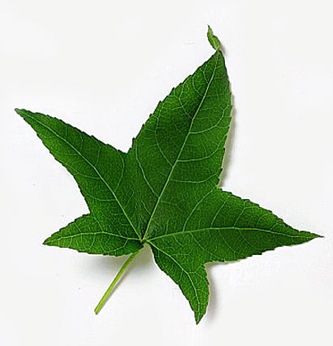](http://www.eattheweeds.com/wp-content/uploads/2012/03/sweet_gum_leaf.jpg)C:\Users\vmohr\AppData\Local\Microsoft\Windows\Temporary Internet Files\Content.IE5\OSHO5RW1\MC900365492[1].wmf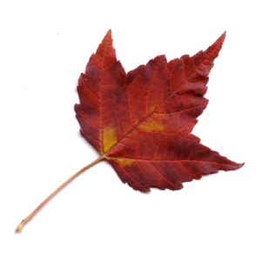[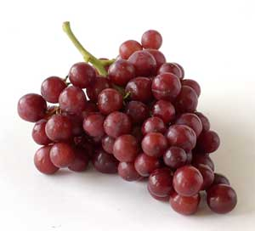](http://www.klesickfamilyfarm.com/main/wp-content/uploads/2011/06/Grapes1.jpg)

[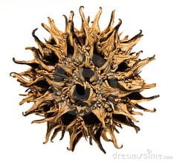](http://www.dreamstime.com/register?jump_to=http://www.dreamstime.com/stock-photos-sweet-gum-seed-pods-image12210033)



Sweetgum Tree

C:\Users\vmohr\AppData\Local\Microsoft\Windows\Temporary Internet Files\Content.IE5\OSHO5RW1\MC900014543[1].wmf

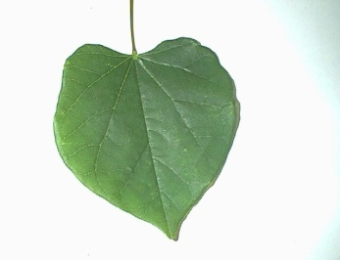

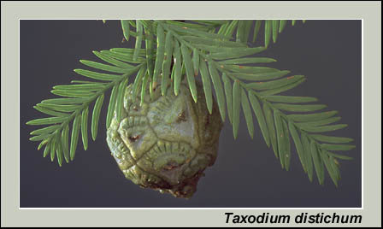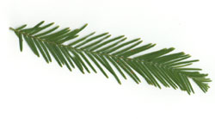

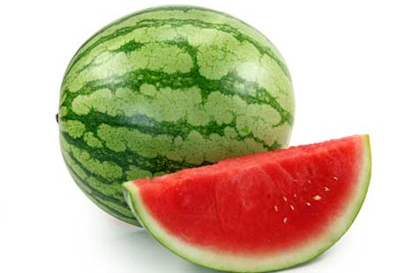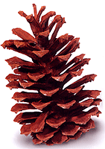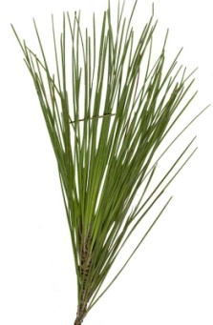

Cypress Tree

C:\Users\vmohr\AppData\Local\Microsoft\Windows\Temporary Internet Files\Content.IE5\CE0BUK3A\MC900014544[2].wmf[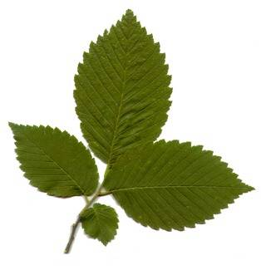](http://0.tqn.com/d/forestry/1/0/w/americanelm.jpg)

Longleaf Pine tree

C:\Users\vmohr\AppData\Local\Microsoft\Windows\Temporary Internet Files\Content.IE5\OSHO5RW1\MC900295588[1].wmfC:\Users\vmohr\AppData\Local\Microsoft\Windows\Temporary Internet Files\Content.IE5\6PG8U8ZR\MC900030117[1].wmf

Ship

Draw a line from the tree to the special item that was found in its “tree-chest”. Some items may have more than one line drawn to them.

C:\Users\vmohr\AppData\Local\Microsoft\Windows\Temporary Internet Files\Content.IE5\6PG8U8ZR\MC900238190[1].wmf

Canoe

Live Oak Tree

C:\Users\vmohr\AppData\Local\Microsoft\Windows\Temporary Internet Files\Content.IE5\6PG8U8ZR\MC900441413[1].wmf

C:\Users\vmohr\AppData\Local\Microsoft\Windows\Temporary Internet Files\Content.IE5\OSHO5RW1\MC900365492[1].wmf

Squirrel

Squirrel



Lightning



**Answer Key**

C:\Users\vmohr\AppData\Local\Microsoft\Windows\Temporary Internet Files\Content.IE5\DMOPFPH7\MC900215944[1].wmf

Chewing Gum

Sweetgum Tree

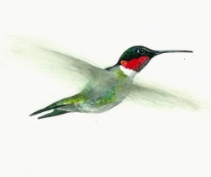C:\Users\vmohr\AppData\Local\Microsoft\Windows\Temporary Internet Files\Content.IE5\OSHO5RW1\MC900014543[1].wmf

Hummingbird

Red Cockaded Woodpecker

C:\Users\vmohr\AppData\Local\Microsoft\Windows\Temporary Internet Files\Low\Content.IE5\EV1E7FKY\MC900084066[1].WMF

C:\Users\vmohr\AppData\Local\Microsoft\Windows\Temporary Internet Files\Content.IE5\DMOPFPH7\MC900351242[1].wmf

Water

Cypress Tree

C:\Users\vmohr\AppData\Local\Microsoft\Windows\Temporary Internet Files\Content.IE5\OSHO5RW1\MC900091073[1].wmfC:\Users\vmohr\AppData\Local\Microsoft\Windows\Temporary Internet Files\Content.IE5\CE0BUK3A\MC900014544[2].wmf

Swamp Rabbit

C:\Users\vmohr\AppData\Local\Microsoft\Windows\Temporary Internet Files\Content.IE5\DMOPFPH7\MC900412454[1].wmfC:\Users\vmohr\AppData\Local\Microsoft\Windows\Temporary Internet Files\Content.IE5\CE0BUK3A\MC900370098[1].wmf

Indigo Snake

B-day Card 1000 Yrs. Old

Longleaf Pine Tree

C:\Users\vmohr\AppData\Local\Microsoft\Windows\Temporary Internet Files\Content.IE5\OSHO5RW1\MC900295588[1].wmfC:\Users\vmohr\AppData\Local\Microsoft\Windows\Temporary Internet Files\Content.IE5\6PG8U8ZR\MC900030117[1].wmf

Ship

Draw a line from the tree to the special item that was found in its “tree-chest”. Some items may have more than one line drawn to them.

C:\Users\vmohr\AppData\Local\Microsoft\Windows\Temporary Internet Files\Content.IE5\6PG8U8ZR\MC900238190[1].wmf

Canoe

Live Oak Tree

C:\Users\vmohr\AppData\Local\Microsoft\Windows\Temporary Internet Files\Content.IE5\6PG8U8ZR\MC900441413[1].wmf

Squirrel

C:\Users\vmohr\AppData\Local\Microsoft\Windows\Temporary Internet Files\Content.IE5\OSHO5RW1\MC900365492[1].wmf



Lightning



C:\Users\vmohr\AppData\Local\Microsoft\Windows\Temporary Internet Files\Content.IE5\DMOPFPH7\MC900215944[1].wmf

Chewing Gum

Sweetgum Tree

C:\Users\vmohr\AppData\Local\Microsoft\Windows\Temporary Internet Files\Content.IE5\OSHO5RW1\MC900014543[1].wmf

Hummingbird

Red Cockaded Woodpecker

C:\Users\vmohr\AppData\Local\Microsoft\Windows\Temporary Internet Files\Low\Content.IE5\EV1E7FKY\MC900084066[1].WMF

C:\Users\vmohr\AppData\Local\Microsoft\Windows\Temporary Internet Files\Content.IE5\DMOPFPH7\MC900351242[1].wmf

Water

Cypress Tree

C:\Users\vmohr\AppData\Local\Microsoft\Windows\Temporary Internet Files\Content.IE5\OSHO5RW1\MC900091073[1].wmfC:\Users\vmohr\AppData\Local\Microsoft\Windows\Temporary Internet Files\Content.IE5\CE0BUK3A\MC900014544[2].wmf

Swamp Rabbit

C:\Users\vmohr\AppData\Local\Microsoft\Windows\Temporary Internet Files\Content.IE5\DMOPFPH7\MC900412454[1].wmfC:\Users\vmohr\AppData\Local\Microsoft\Windows\Temporary Internet Files\Content.IE5\CE0BUK3A\MC900370098[1].wmf

Indigo Snake

B-day Card 1000 Yrs. Old

Longleaf Pine Tree